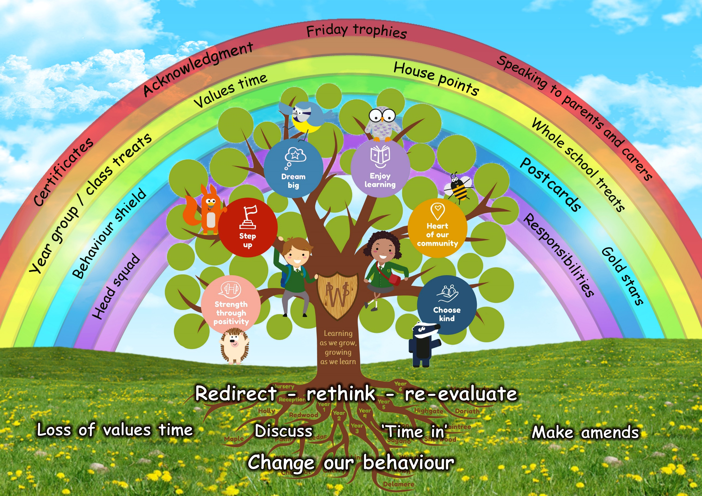

School Council – Task 2- Write Up
Dear School Council Reps,
Please can you ask your class the following questions and get some feedback.
Thinking about our New ‘PW Way Behaviour Visual’
What is working well?  (Up to 10 points) | What is not working as well?  (Up to 3 things) | What would be the solution? | What would you like to add?  (up to 3 things)
- Linked to values  - Values Time  - No name and shame  - Redeeming values time  - Colourful  - Conversations with the teacher about behaviour  - Can see rewards and lots of them  - Doesn’t bring to much attention on individuals  - Focuses on positives  - Chance to get values house points | - Too small to see  - People taking advantage of no traffic lights (playtimes – know they won’t go onto amber?)  - Not interactive  - Children felt that some behaviour goes unseen if not put on the chart (we discussed if we always needed to see if someone had done the wrong thing?) | - Make it bigger  - Make sure that if someone has done something wrong, then they do get 5 minutes off Values Time like it was before. (We discussed this could happen but we might not always see)  - Make sure that all problems are talked about with teachers  - Sammy Squirrel ‘Step Up’ Rules – School Council/ Head Squad to work on with Mrs Bretayne and launch | - Class Step up Challenge in Spring Term  - Sammy Squirrel Step up Rules launched in Spring Term.  - Making more of the Zones – it has started but we would like to do more with this

Thank you to Anaaya and Sarvasvi for writing up the notes.
Can we meet on Tuesday 15th November at 2.30pm to launch our next very Big Challenge!
Miss Marriott and Mrs Bennett

